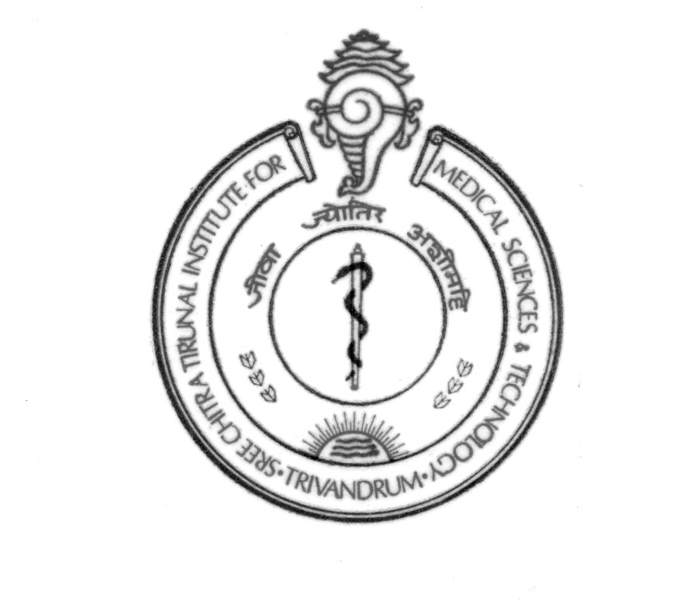

SREE CHITRA TIRUNAL INSTITUTE FOR MEDICAL SCIENCES & TECHNOLOGY

THIRUVANANTHAPURAM – 695011, INDIA

(An Institute of National Importance under Govt.of India)

Phone-(91)0471-2443152 Fax-(91)0471-2446433,2550728

[Email-sct@sctimst.ac.in](mailto:Email-sct@sctimst.ac.in) Web site – www.sctimst.ac.in

**CERTIFICATE OF TRANSFER OF CHARGE**

**(Retirement/Relieving/Transfer)**

Certified that we have taken over/handed over charge of ______________________________

(Section/Divison/Department) on the date of ______________ FN/AN.

Items handed over/received include all official documents related to Section/Divison/ Department, stock verified report, official emails, institute equipments including PC, Printer if any. It is also certified that new in charge has been trained/briefed about the day to day work of the Section/Division/Department.

Relevant particular required vide order No _______________________________ dated _______________ is furnished below.

(use separate sheet if required)

(Emp. Code, Name & Signature of Officer handling over charge) (Emp. Code,Name & Signature of Officer taking over charge)

Remarks of the HOD concerned

Forwarded to P & A Divn. for documentation Signature and seal of HOD